Grade 7 Accelerated · Unit 4 · Assessment  Solving Problems with Rational Numbers  Form B · 29 points | Name__________________  Date__________________  Period________________

Show your work. One point for each lettered part.
Part 1. Operations in Scientific Notation 12 points
If an earlier part is wrong, a later part still earns its point when the right operation is applied to your own earlier answer — but only if that work is on the page.
1. Add or subtract. Write each answer in scientific notation.
a. 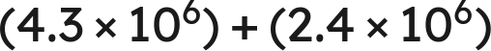 1 pt

b. 1 pt

c. 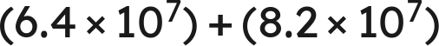 1 pt

d. 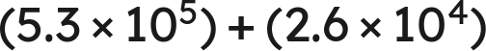 1 pt

2. Multiply or divide. Write each answer in scientific notation.
a. 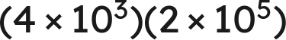 1 pt

b. 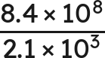 1 pt

c. 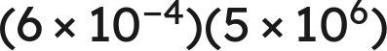 1 pt

d. 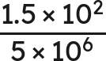 1 pt

3. Which is the value of 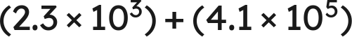 ? 1 pt
○ A. 
○ B. 
○ C. 
○ D. 

4. Select ALL of the expressions whose value is 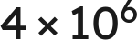. 1 pt
□ A. 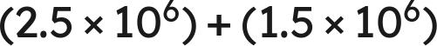
□ B. 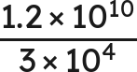
□ C. 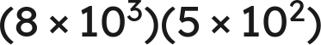
□ D. 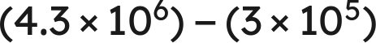
□ E. 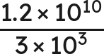
□ F. 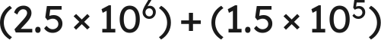

5. Devon writes . Name the two mistakes he made, and give the correct sum. 1 pt

6. A number is multiplied by  and the product is 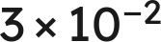. What was the number? Write your answer in scientific notation. 1 pt

Part 2. Real-World Problems in Scientific Notation 4 points
If an earlier part is wrong, a later part still earns its point when the right operation is applied to your own earlier answer — but only if that work is on the page.
7. Solve. Write each answer in scientific notation. Do not round.
a. A rectangular plate measures  mm by  mm. Find its area. 1 pt

b. A vehicle travels  km in 8 hours. Find its average speed. 1 pt

8. Solve. Write each answer in scientific notation. Do not round.
a. Two lengths are measured:  mm and  mm. Find their sum. 1 pt

b. Two masses are measured: 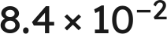 g and 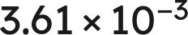 g. Find their difference. 1 pt

Part 3. The Order of Operations with Exponents and Radicals 13 points
If an earlier part is wrong, a later part still earns its point when the right operation is applied to your own earlier answer — but only if that work is on the page.
9. Evaluate each expression.
a.  1 pt

b. 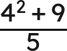 1 pt

c. 45 ÷ 9 · 3 1 pt

d. 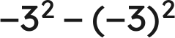 1 pt

10. Evaluate each expression.
a. 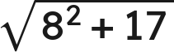 1 pt

b. 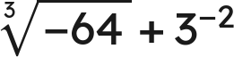 1 pt

c. 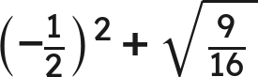 1 pt

11. A square patio of side 12 feet is sealed at 2.60 dollars a square foot, with a flat 75 dollars for delivery.
a. Write an expression for the total cost. 1 pt

b. Find the total cost. 1 pt

12. Which is the value of 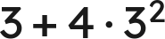 ? 1 pt
○ A. 27
○ B. 63
○ C. 225
○ D. 39

13. Select ALL of the expressions whose value is 8. 1 pt
□ A. 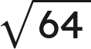
□ B. 64 ÷ 4 · 2
□ C. 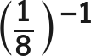
□ D. 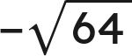
□ E. 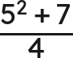
□ F. 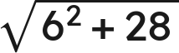

14. Tomas writes . Explain why he is wrong, and give the correct value. 1 pt

15. A square tile has an area of 225 square inches. A second square tile has a side twice as long as the first. What is the area of the second tile? 1 pt

